# Fall Complete Portfolio Documentation 2022

**Make sure to scroll to the end to see the rubric.

**Your name: Roger Barber**

**Link to your deployed site: https://rogerbarber.github.io/final_project339/production.html**

**Link to your Github repository: https://github.com/rogerbarber/final_project339**

1. Italics and color-change, but one of high contrast. Current page should be italic text and changes from dark color (green/black) to white, making it easy to tell if one is colorblind.
2. Skip to content is available on all pages and on the first tab.
3. Grid is used in all of the headers. I utilized changing the grid template to add more rows at the breakpoints. I used similar aspects that we used in the homework for my page structure, but I used it to style the header as well. I utilized the larger grid to better display the photos since they are large and the center-piece of my project. I utilized the grid area property to force images and text to have different sizes based on the screen size. Removing grid destroys my page display.
4. Flex is only utilized on my coffee preparation page. I used a similar layout and flex direction to the homework, but I utilized the order property to force my flex items to be in a similar display to my grid pages. I utilized flex-basis properties to change the size of the items to mimic my grid layout and maintain a constant design. Removing flex makes it a complete mess.
5. I utilized a nice background that has good textures, along with a natural color scheme and transparency to make the floating boxes look more visually appealing. I also used strong borders to make my images pop out and make them easy to distinguish from the background. Also, I imported a new font that looked better than the default fonts and implemented it in my code. Everything fits the natural theme of coffee. Also, I utilized border radius properties in my header and used border and padding to create a “picture frame” effect on my pictures, utilizing a transparent background to look like a picture padding.
6. My breakpoints are at 720px (the average tablet size) and 1200px (the average screen size for a small laptop device). I increased the sizes of the images based on the screen to allow people to look at the pictures in their full fidelity on a large website, while making them easier to scroll through on a smaller device. On a tablet, the stagger view is utilized to keep the text readable (taking up 2 columns) and the image a bit smaller (at 1 column), with lightbox utilized to make the images bigger on demand. On the desktop view, the images take up a huge amount of space, and the text is a bit smaller, so the lightbox view is actually used for the opposite effect – one can see all of the images in a smaller, more manageable format that is easily clicked through.
7. See above.
8. Include a screenshot of **all** pages validating on aXe and Wave. Make sure that we can see the URL in the screenshot.

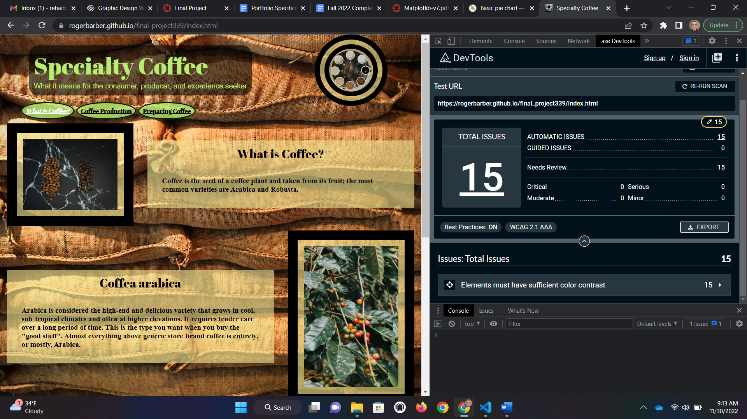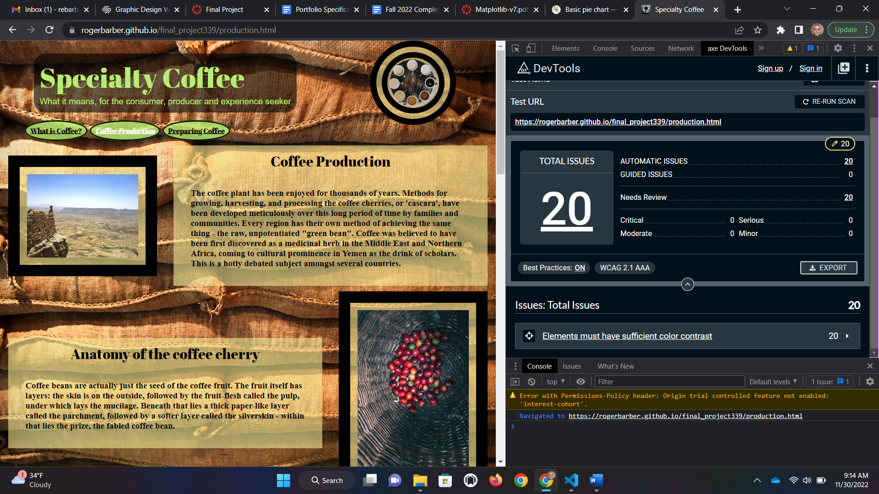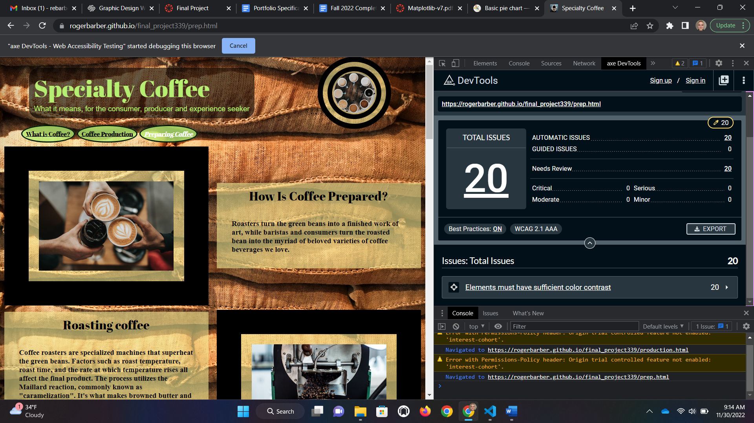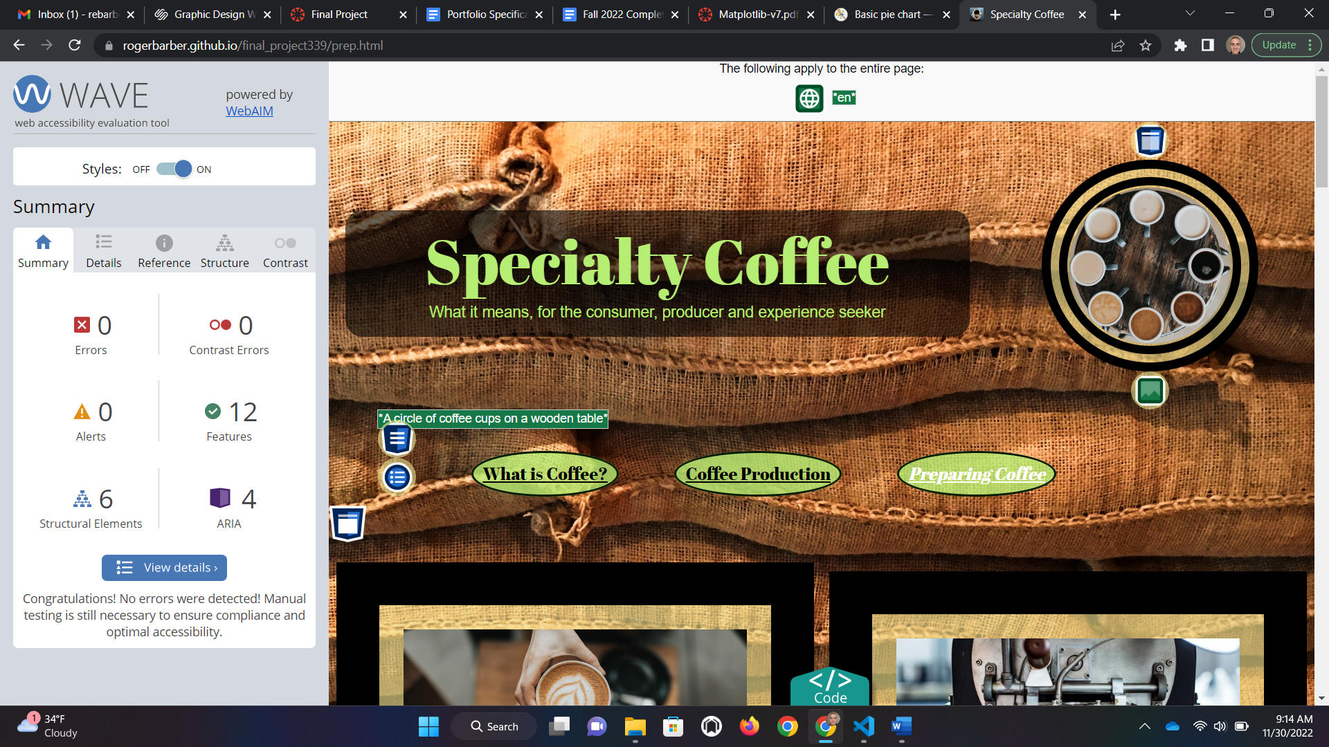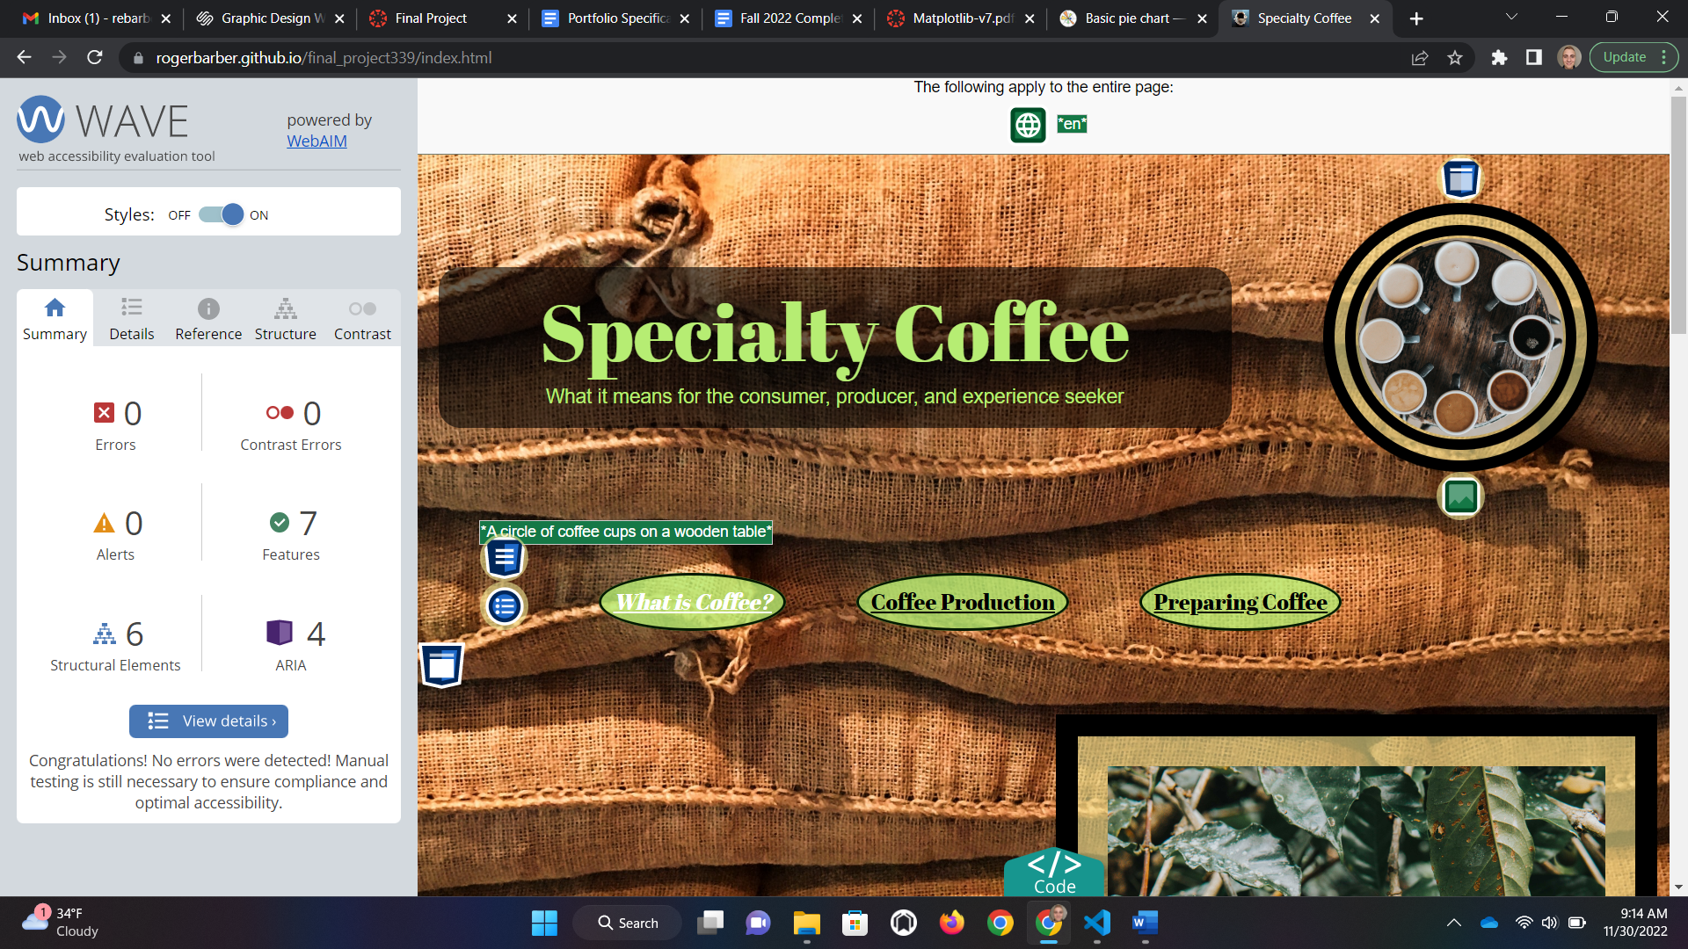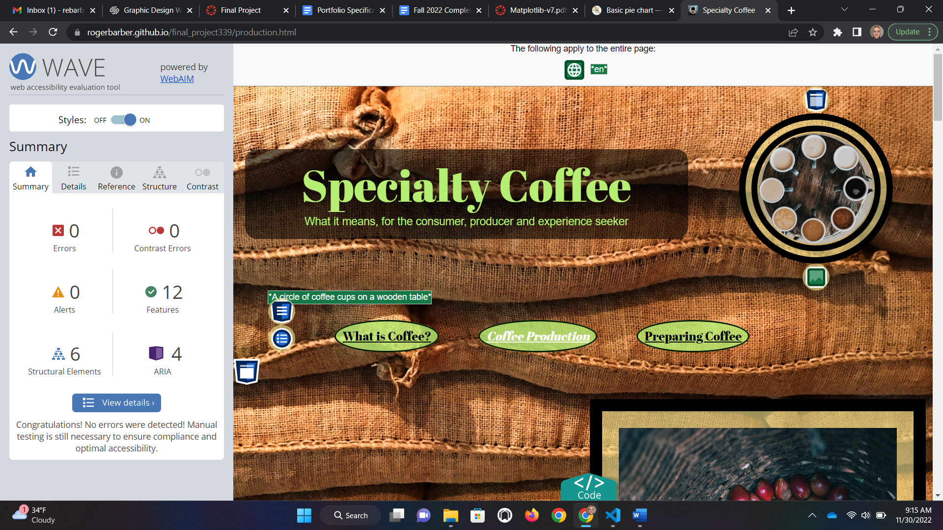

1. Beyond manual testing, I used colorblind manual testing. Everything that I have is high contrast and easy to tell where things end and begin. I do not make color a requirement for navigation. Also, I made sure to create a lot of space for clicking on objects for those with difficulty clicking or interacting with certain buttons. Also, a prefers reduced motion query turns off my smooth scrolling features and my parallax background to make sure people with vestibular motion disorders don’t have issues with my site.
2. The reset sheet is present, the viewport tag is included, filenames are easy to remember and make sense for what they are, and the HTML and CSS sheets are organized and well-commented to make sure that someone can go through and understand what I have written, and where, and why.

Fill in your expected score and we will use it as a starting point. (If you give a lower score than we think you deserve we may raise it. If you give yourself credit for doing something you didn’t complete we will make an extra deduction.)

|  |  |  |
| --- | --- | --- |
| **Criteria** | **Your Expected Score** |  |
| The navigation must clearly display the current page within the nav element. As you visit each page, point out how the navigation bar changes to clearly indicate which page you are currently viewing. Don't forget, color alone should never be used to signify important information. | 5/5 |  |
| Each page should contain a main section that can be reached using a Jump to Content option with the first tab on the page. Main must be after the navigation. Make sure to check that "Skip To Content" works on EVERY page. | 5/5 |  |
| Grid - used effectively.  What elements use grid and which pages are these elements on? How did you use grid differently from the homework? | 10/10 |  |
| Flex - used effectively.  What elements use flex and which pages are these elements on? How did you use flex differently from the homework? | 10/10 |  |
| Visually appealing What did you do to make your page particularly appealing? How did you come up with your color scheme? Tell us more about your font choices, image editing, etc. I am sure there are things that you did that we can't easily see. | 20/20 |  |
| Tell us about your Responsive Design. What is your tablet breakpoint and why did you pick that particular value for your first media query? What is changed in the layout? What is changed in the styling ? Were you careful to not duplicate unnecessary code? | 10/10 |  |
| Tell us about your Responsive Design. What is your desktop breakpoint and why did you pick that particular value for your second media query? What is changed in the layout? What is changed in the styling ? Were you careful to not duplicate unnecessary code? | 10/10 |  |
| Validation | 10/10 |  |
| Accessibility, diversity and inclusion. Include a summary of the steps you took to ensure that your site addresses accessibility, diversity and inclusion. | 10/10 |  |
| Presentation | 10/10 |  |
| “Extras” – What did you do above and beyond the required? | 10/25 |  |